Changing the Address on SingleTact Sensors
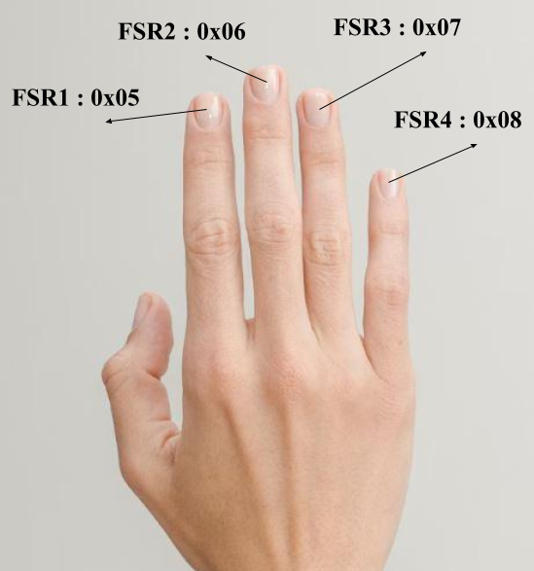
Figure 1 : Address for Each Finger of the Hand Device

- Ensure Arduino IDE 2.3.8 (or similar version) is installed and connect the Arduino Nano to the computer using a USB cable. (refer to Connecting SingleTact Sensor to Arduino below)
- Select the ‘Arduino Nano’ board and the correct COM port that connects to the SingleTact sensor.
- Open the Arduino file ‘ADDRESS.ino’ and verify  the file to ensure the sketch is compiled, then upload  the sketch to the Arduino Nano board.
- Once uploaded, the Arduino file ‘ADDRESS.ino’ scans all 127 possible I2C addresses, and prints any devices found within the serial monitor. It should display a message “Found device at 0x__”. If there are errors, ensure the baud rate of the serial monitor is set to 115200. (note: all other serial monitors should be closed to prevent miscommunication)
- Once an address has been found, take note of the address as it is required in the next steps.
- Open the Arduino file “SingleTactAddressChange.ino”. This file will change a SingleTact sensor's I2C address from the initial address to the desired address. It does this by using a 5-byte write command over I2C, to ensure the new address is saved after the sensor is powered off.
- Before running the program, the two main variables that require changing are oldAddress and newAddress. Enter the oldAddress that was found in Step 4, in the format 0x_ _. Then enter the desired address (newAddress) for the specific finger, as shown in Figure 1, in the same format 0x_ _.
- Verify  the file to ensure the sketch is compiled, then upload  the sketch to the Arduino Nano board. Keep in mind the baud rate of the serial monitor is set to 57600. (note: all other serial monitors should be closed to prevent miscommunication)
- A successful address change should show the following within the serial monitor :
“PPS UK: Changing SingleTact slave address.”
“Sent command to change address from 0x_ _ to 0x_ _.
- Finally, double check that the address of the SingleTact sensor has been changed by checking the address again in ‘ADDRESS.ino’ by repeating Steps 1 - 4. The new address should be displayed, if not, repeat Steps 6 - 9 until the address has been changed.
- After the address of all 4 FSR sensors have been changed to the correct arrangement as shown in Figure 1, the Arduino is ready for connection. Before running the Python game simulation, the Arduino file “Arduino_20251111.ino” must be opened and verified  to ensure the sketch is compiled, then uploaded  to the Arduino Nano board. The raw force values of each sensor will be displayed in the serial monitor with the format “FSR: _, _, _, _”. Keep in mind the serial monitor baud rate is 115200. (note: all other serial monitors should be closed to prevent miscommunication).
- Finally, the serial monitor in the Arduino program should be closed before running the Python game simulation to prevent miscommunication.

Connecting SingleTact Sensor to Arduino
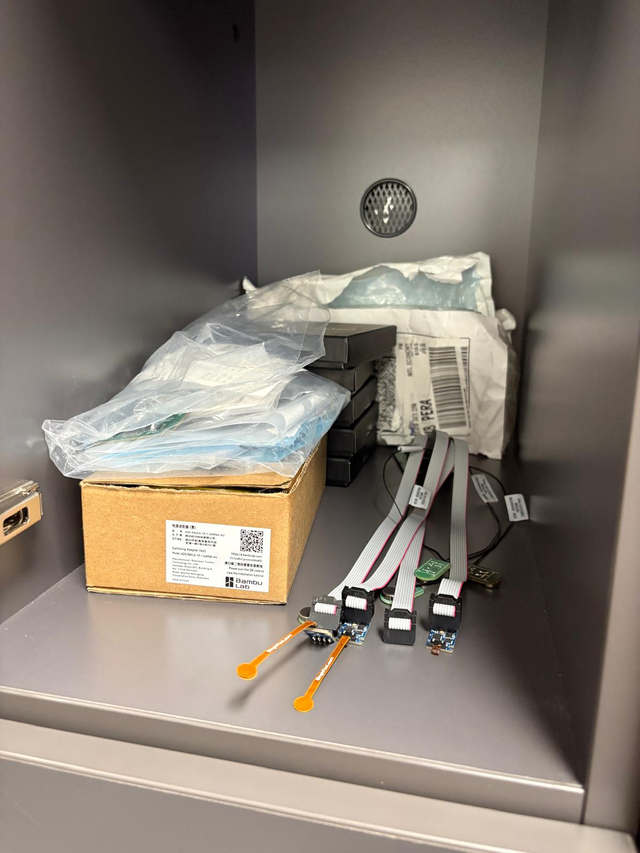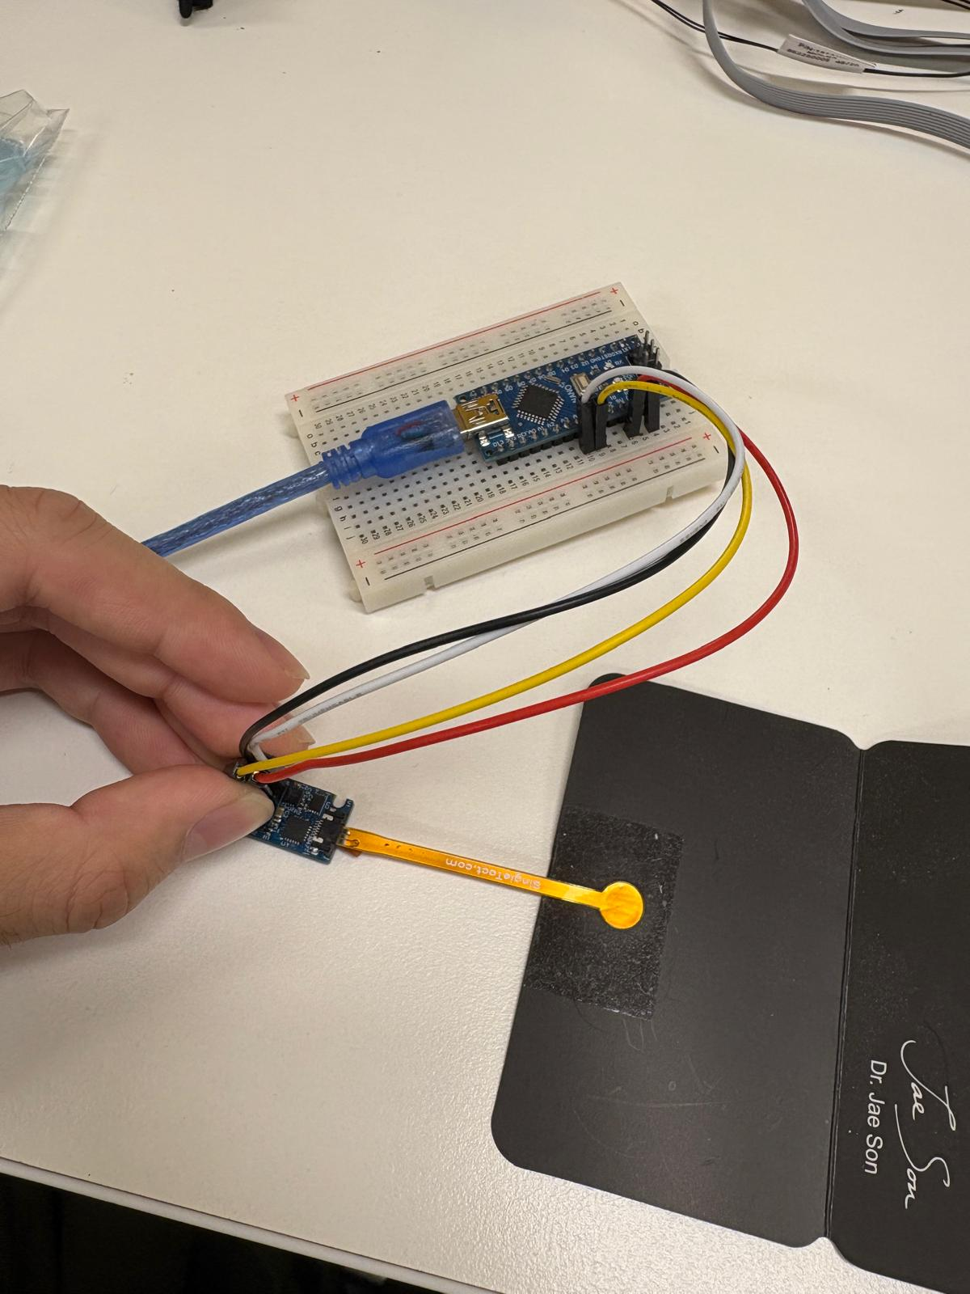

The SingleTact sensor can be connected to the Hand Rehabilitation device if it has been desoldered to accommodate male connecting pins (shown on the left), or it can be connected to an external Arduino Nano for a quick address change, provided the SingleTact sensor has not been desoldered yet (shown on the right).

Follow the SingleTact User Manual and refer to Page 28 for the pin locations and wiring arrangements.

Running Post-Analysis on Rehabilitation Data
- analyze_baseline_drift_modified_newtons.R
Reads ‘raw/’ CSV’s and converts the raw sensor data into Newtons for the entire session. It computes two types of newton readings which have been processed in different ways. The first way is the corrected raw value, where a static offset of -255 is applied to the raw sensor values before converting into newtons. The second way is utilising a ‘locally zeroed’ method, where the raw sensor value is subtracted by the average of the 250ms immediately before each press. This dynamic local zeroing method aims to reduce the negative effects of baseline drift, hence this data should be utilised for a more accurate rehabilitation analysis. The file produces both force trend plots on a graph, with the respective linear regression trend lines for both raw and zeroed data. The output graphs are located within ‘Force Analysis Plots’.
TO RUN, OPEN RSCRIPT WITHIN FOLDER AND PRESS WITHIN VSCODE

- analyze_baseline_drift_modified.R
A simpler version of ‘analyze_baseline_drift_modified_newtons.R’ where it reads ‘raw/’ CSV’s and displays the raw sensor data for only stimulus and response events across the entire session. The raw sensor data has a static offset of -255 applied to simulate a reading of 0 when no force is applied to the sensor. This program is useful for finding the baseline drift before and after a session has been completed, to find the difference in terms of the raw sensor count value. The output graphs are located within ‘Stim Response Plots’.
TO RUN, OPEN RSCRIPT WITHIN FOLDER AND PRESS WITHIN VSCODE

- analyze_baseline_drift.R
This program was used in the initial phases of assessing the baseline drift. It reads the ‘raw/’ CSV’s and plots the raw FSR1 waveforms for the first 5 trials of each session. The blue and red dotted lines represent the stimulus and peak response respectively. Green dots have been placed in 50ms intervals before every stimulus to evaluate the best window to average the dynamic baseline. As a result, a 250ms window has been chosen as this window provides the most stable baseline calculation. The output graphs are located within ‘Response_Waveforms’.
TO RUN, OPEN RSCRIPT WITHIN FOLDER AND PRESS WITHIN VSCODE

- process_force_peaks.py (teasdale algorithm + peak extraction)
This program is placed within the same folder as the ‘raw/’ CSV sessions. Teasdale onset detection is used to figure out when the finger actually starts moving. It analyses the raw FSR waveform mathematically, and applies a low pass filter to smooth out the force signal, computes the rate of change (velocity), then finds the earliest moment the force started rising meaningfully (before noise or drift can be mistaken for a press). This provides a more accurate reaction time (ms) than the game’s own timing. It can find the maximum raw FSR value recorded on each of the 4 fingers – not just the stimulated one, therefore crosstalk and unintended presses can be detected. It processes every CSV it finds and outputs one result file per session into ‘/raw/Processed Data/’.
TO RUN, change directory (cd) to ‘/raw’ within the terminal, and run :
“python process_force_peaks.py”

- max_peak_analysis.R
This program finds the highest force value (raw sensor value) recorded across the 4 fingers across all participant trials within the ‘/raw’ CSV folder. The program outputs a single ‘overall_peak_force_summary.csv’ to showcase a participant's maximum force output, and is saved within the ‘Peak Analysis’ folder.
TO RUN, OPEN RSCRIPT WITHIN FOLDER AND PRESS WITHIN VSCODE

- noise_analysis.r
This program calculates the Signal-to-Noise (SNR) ratio by measuring the sensor noise during quiet inter-trial intervals and comparing it against the average press force. It reads every CSV file within the ‘/raw’ folder for evaluation. The noise is calculated by identifying all stimulus event times, and builds a window around each one (200ms before to 1.5 seconds after stimulus event). Everything outside this window is considered a true resting baseline. It then takes a standard deviation of the FSR readings during these quiet inter-trial intervals, this standard deviation is the noise floor for each sensor.

The signal is calculated by taking every stimulus event, and finding the peak force on the stimulated finger within a 1.2 second window after the stimulus. It then averages those peaks across all trials to get a mean signal level per finger. After each file is processed, it pools the data together and computes a grand average across all participants where SNR = grand average signal / grand average noise. The output file is saved as ‘grand_average_snr_summary.csv’ within the ‘Noise Analysis/’ folder.
TO RUN, OPEN RSCRIPT WITHIN FOLDER AND PRESS WITHIN VSCODE

- repeatability.r
This program checks how consistently each sensor responds across repeated presses of the same finger. It reads all CSV files within ‘raw/’, then extracts the peak force on the stimulated finger for every trial. It then groups the trials into segments, so segment 1 is trials 1-50, segment 2 is trials 51-100 and so on. For each segment, the mean force, SD (standard deviation) and CV% (coefficient of variation) are calculated. It aims to evaluate the average peak across the segment, how much the peaks vary, and calculate a normalised measure of consistency (CV%). It plots the mean force per segment as a line graph with error bars (+1 SD), one line per finger. Outputs a CSV and PNG of repeatability stats and a scatter/box plot per participant within the ‘repeat/’ folder
TO RUN, OPEN RSCRIPT WITHIN FOLDER AND PRESS WITHIN VSCODE

- FingerRawForEachBlock.R
This program reads the ‘/raw/Processed Data/’ folder containing CSV’s, and generates peak force plots split by gameblock (BLOCK 1: pretest trials 1-50, BLOCK 2: structured 51-550, BLOCK 3: aftertest 551-600). For each block, it creates a 4-panel plot (one panel for each finger). The 4-panel plot showcases a grey line connecting all trial peak force values over time, coloured dots for each finger (red, blue, green, purple), and larger, opaque dots on the finger that was actually stimulated within the trial (to identify whether non-stimulated fingers registered a force). The output is a PNG for BLOCK 1, BLOCK 2 and BLOCK 3 to the ‘/raw/Trial Plots/’ folder.
TO RUN, change directory (cd) to ‘/raw’ within the terminal, and run :
“Rscript FingerRawforEachBlock.r”

- Data_analysis_Final.r
This program reads the ‘condensed’ CSV files which have been placed in the ‘data/’ folder as opposed to the ‘data/raw’ folder. The program is a statistical pipeline that assesses the motor sequence learning of multiple trials conducted on the hand rehabilitation device. It divides the session into 7 Blocks numbered 0-6 to represent :
- Block 0 : pretest (50 random trials)
- Block 1-5 : main game, split into 5 chunks of 100 trials
- Block 6 : posttest (50 random trials)

The script produces three PNG’s which showcase the full reaction time spread per block, a model-estimtated mean reaction time per block with 95% confidence intervals, and each participant's learning curve (grey line) which is overlaid with the group mean (coloured). The images are placed within the ‘Analysis Plots’ folder.

NOTE : The library path containing the necessary libraries must be changed at the TOP of the script e.g. .libPaths(c(“C:/Users/…/library”, .libPaths())). Ensure the correct library path is entered before running.
TO RUN, OPEN RSCRIPT WITHIN FOLDER AND PRESS WITHIN VSCODE
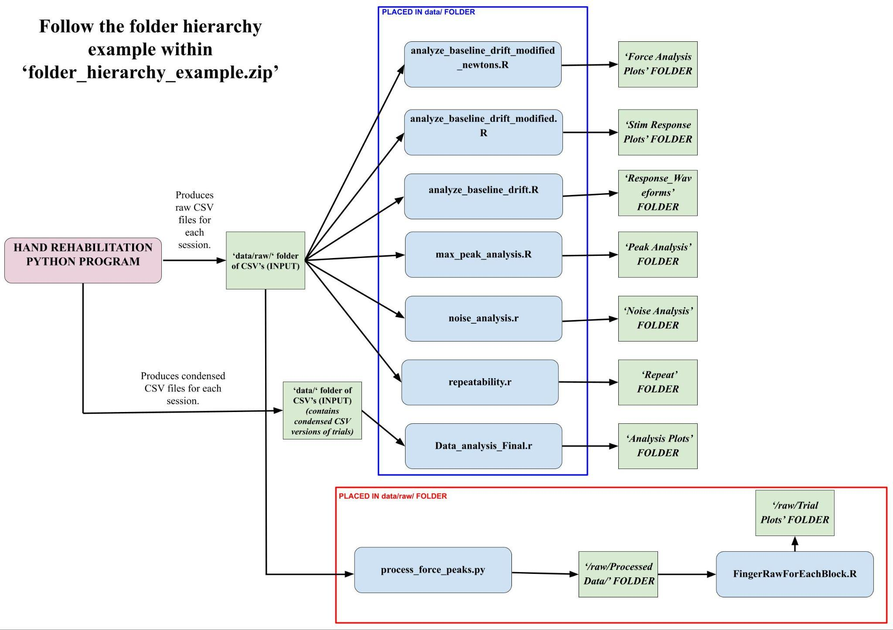
VSCode Python/RStudio Libraries and Packages Required :
Python :
- numpy
- scipy
- pygame
- pyserial

RStudio :
- readr
- dplyr
- tidyr
- stringr
- purrr
- ggplot2
- lme4
- lmerTest
- emmeans
- pbkrtest
- rstudioapi

